**Lab2.Ogbondah**

**LAB 2**

**SECTION SE 185**

**Chimzim Ogbondah**

**SUBMISSION DATE: 9.11.2018**

**DATE: 9.11.2018**

# Problem

1. The purpose of part one of this lab was to be able to use simple outputs to print our name, course title, and the date each on a new line. The objective of part one was to become more comfortable with outputting things to the terminal.
2. The purpose of part two of this lab is to create a simple program that contains input and output commands that will first calculate the area of a triangle based on the users inputs and then next calculate the volume of the prism. The results must be printed to the terminal. The objective of this part of the lab was to be more comfortable with I/O and being able to use simple arithmetic functions.
3. The purpose of part three of the lab is to catch syntax errors with the printf statements. Once the statements are changed and the program runs with no errors comments need to be added to identify what was done to fix the syntax errors. The objective of this part of the lab is to be more comfortable with C syntax as well as understanding the process on how to look for errors in a program.
4. The purpose of part four of the lab is to create a simple program using basic arithmetic functions to calculate given equations as well as using constants in equations and using different math functions to solve harder functions. Each equation needed to be solved for with the equation and the correct answer printing to the terminal. The objective of this lab was to understand how order of operations work inside the program as well as understanding and testing how math different math functions and constant variables work.
5. The purpose of part five of this lab was to create a simple arithmetic program that would calculate the missing side of the triangle using pathgroems theorem based off input statements for the first two sides that the use input. The missing side was the printed to the terminal. The objective of this lab was to be more comfortable with the math functions as well as testing the different syntax for different defined variables (double vs int).

# Analysis

1. The problem for part one states that we must have our name, title of course, and the date printed to the terminal. Therefore for the problem output consist of 3 printf statements all ending with a new line, and each one meets one of the desired outputs. The only reasonable and time efficient method is to use 3 printf statements.
2. The problem for part two states that we must compute the area of a rectangle and then compute the volume of a prism which are provided by the user. Therefore the problem input is any range of numbers inside the double definition for both the rectangle and the prism. The only reasonable equation to use for the area of the rectangle is (length x width or x * y) and for the volume equation (length x width x height or x * y * z)
3. The problem for part three states that we must correct the inside the printf statements and followed by adding comments to verify what the problem was. Therefore the problem comment consisted of explanations as to why the corresponding printf statement had errors and how it was fixed. The only reasonable comment to use was /* being that it was simple syntax errors and so the explanation of what was wrong didn’t need multiple lines. (two problems were changing %lf to %d because it was an int variable and deleting two pretenses and adding one before using for the first statement and then for the 3rd statement changing %d to %lf because the variable was a double)
4. The problem for part four states that we must compute the right answers for the given equations by understanding order of operations and use constants to find the area of a circle, feet conversion to meters and temperature conversion. Therefore, the problem output printed out the equations with the answers attached to them based on their computation from above. The only reasonable equations to use for the simple order of operations was to follow the guide from the lab instructions which used different orders of / * and () to give different answers. For the area of a circle making the circumference a constant, and then dividing it by two, taking it to the power of two and then finally multiplying it by 3.14 (r^2 * 3.14 = area). For temperature conversion the only reasonable equation to use was F=(tempInF – 32) * 1/8. Finally, for feet conversion converting the feet knowing the conversion of how many feet were equal to 1 meter and then converting. (14 ft * .0348 meter).
5. The problem for part five states that we must find the missing side length using pathagreoms theorem based on the input values given by the user. The missing side length value was then printed to the terminal after all the calculations were done. Therefore, the problem input was any double (floating) number from and positive number greater than zero. The only reasonable equation to use was A^2 + B^2 = C^2. Since A and B received inputs from the user those values were taken to the power of two and then added together and put under the sqrt function so that the missing side length could be found.

# Design

1. Our problem was to create a program that printed three different things to the terminal. Our first and last name, the title of our current course, and finally the days date. I used a simple decision process in which I chose to give each constraint its own printf statement ending with a new line.

Using the basic outline above I met the criteria and inserted them into the outputting printf statements where they were later printed to the terminal. To ensure I did this correctly I looked over the instructions form the Lab.

1. Our problem was to compute an arithmetic algorithm that would first compute the area of a rectangle based off the users inputs, and then secondly compute the volume of a prism based again off the users inputs. I used a step by step process to divide the problem into smaller tasks
   1. Get the length and width value (x and y)
   2. Compute the area of the rectangle (x * y)
   3. Print the area to the terminal
   4. Get the length, width, and height (x, y, and z)
   5. Compute the volume of a prism (x * y *z)
   6. Print the volume of the prism to the terminal

Using the outline above, I designed my program by using steps. I assigned all numerical values with (int) being that we were using whole numbers for this program. I then added scanf() statements with corresponding printf() statements to ask the user for the values we needed and then assigning their input into the correct variable. We finally printed the results of our computation to the terminal so that way the user could see the results. To make sure that everything was correctly done I looked over the lab instructions for guidance on what confused me.

1. Our problem was to fix the syntax errors with each printf() statement and then insert corresponding comment to state what fixed the problem. I used a step by step process to breakdown and solve the problem
   1. I used a method of checking the printf() statements (Looked to make sure the syntax was right and then proceeded to look inside the actual statement to make sure everything was right)
   2. Once the error was found I used /* or single line comment because the errors inside the printf() statement were simple.

Using the outline above, I fixed the program by using steps. I scanned over all the printf() statements until the error was found and then finally used single line comment (/*) to type what syntax error I fixed with the printf() statement.

1. Our problem was to compute a series of equations to get the correct answers by using order of operations built in to the C program as well as using PEMDAS to give different answers using both int and floating variables. As well as using finding the area of a circle, converting 14 feet into meters and finally converting 79 degrees to centigrade. I followed the PEMDAS instructions for the first part and then a step process for the second parts.
   1. I used the instructions for the lab guide to compute the correct answers (2.0 / 3 * 3 vs (2.0 / (3 * 3) because the two equations compute different answers and with floating variables give decimals places)
   2. Took the circumference of the circle and divided by 2
   3. And then took the answer to the power of 2
   4. Finally took that answer * 3.14
   5. For feet conversion I took the conversion of 1 ft into meters and multiplied by 14
   6. For temperature I took 79 – 32
   7. And then took that answer * 1/8

Using the outline above, I computed the answers for the first part and assigned each equation a letter a – g and defined the letter either as and int value or a double value based on what the lab instructions said. Finally, I printed the answers to the equation to the terminal, so the user could see the equation with the corresponding answer. I then assigned the circumference of the circle as a constant because it was something that wouldn’t change and used the equation r^2 * 3.14 to compute the area of that circle. I assigned the circumference divided by two to a double value and then put that variable in the power function and then multiplied it by 3.14. the ending equation was a double value seeing that the number would have a decimal in it. For feet conversion I assigned a variable to double and then set the feet conversion to meter inside that variable and the printed the result. (14 * 0.0348). Finally, I assigned the variable that would hold the temp conversion as a double. I then used the equation C = (F – 32) * 1/8 to compute my answer and then printed it to the terminal.

1. The problem was to create an algorithm that took the users input and for two sides and then found the answer to the missing side of the triangle using pathagroems theorem. I used a step by step process to breakdown the problem.
   1. Took the side length of A from the user
   2. Took side length of B from the user
   3. Took A^2 + B^2 and put it into a filler variable
   4. Finally took the filler variable and put into the sqrt function

Using the outline above, I computed the answer for the missing variable and then printed it to the terminal for the user to see. I assigned all three variables to double because the user could have an positive number, and then I used scanf() statements with corresponding printf() statements to gather the side lengths from the user. Then the side lengths were put into the equation A^2 + B^2 = C^2. The values for A and B were found and then the sqrt was taken from those values to compute C which was also assigned a double value as a decimal could be possible. Finally, I printed the results to the terminal so the user could see the missing side length.

# Testing

1. In order to verify the results of the solution were correct, I input my data into the printf() statements and then ran the code. There wasn’t an issue, but to verify it wasn’t a fluke I ran it two other times with different characters.
2. To make sure the results of the solution were correct, I complied and ran the program for both area of the rectangle and volume of the prism and compared the answers with what I had on my calculator. I tested this out two other times to ensure that my algorithm worked and there were no hidden flaws.
3. To be certain that my results were correct, I checked my comments for what I fixed and then looked over the syntax again. I then compiled the program and ran it. They were simple printf() statements so since the program ran with no errors I could conclude that the errors were fixed.
4. In order to verify the results of the solution were correct, I did the functions using the specific order of operations and crossed checked my answers with what the program was printing out. I then made sure the conversion from feet to meters was correct and then check the answer with the one I got from my calculator. I then used the equation for temp conversion and crossed checked my answer with the codes answer. For the area of a circle I kept getting a wrong answer, and so I looked back into my code to realize that the double for the last step wasn’t bracketing together. Upon fixing this problem my algorithm began printing out the correct answer.
5. To makes sure the result of the triangle were right I computed the answer on my calculator and checked with the codes answer. The Code kept spitting out 0.00 every time with an error code of filler has no arguments, so I went back to the code to realize that there was already an input filler variable and I didn’t need to input it. Upon fixing this problem I reran the code and checked my answers again.

# Comments

In doing this Lab I learned that double checking your work to make sure everything lines up correctly is key. I became very frustrated not understanding why my last part of the lab was giving my 0.00, and simply checking to make sure everything in my code could have saved me time. Through the lab I learned how to manipulate the pow functions and sqrt functions more to the point that adding a second variable to either pow() or sqrt() isn’t necessary because I can compute my algorithm in the parenthesis as one argument and cut a line of code. I also learned the importance of comment as commenting all my code helped me find where my problem was in part 4 of the lab because I was able to pinpoint which equation was compute the wrong answer. I still need to work on my commenting skills as I would comment the printf() statements explaining what happened in the line above instead of just commenting both lines

# Source Code

<Use NPP Exporter to PASTE source code>

Source code is listed 1-5

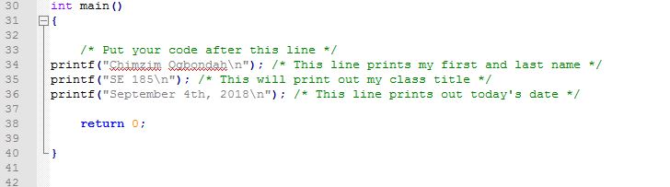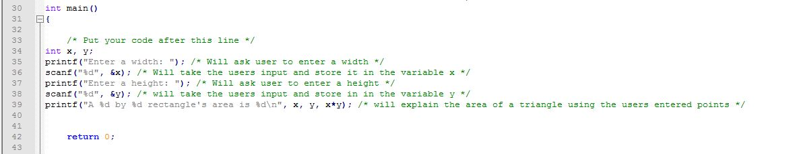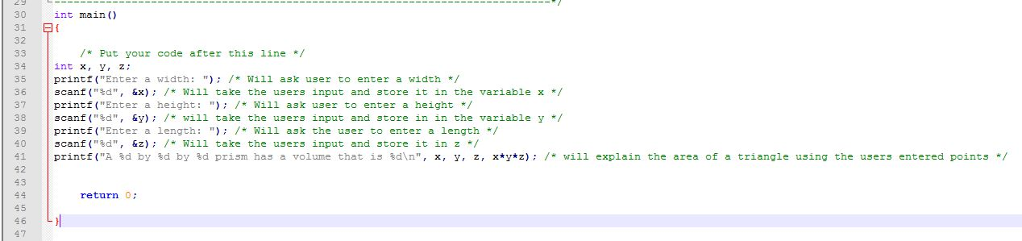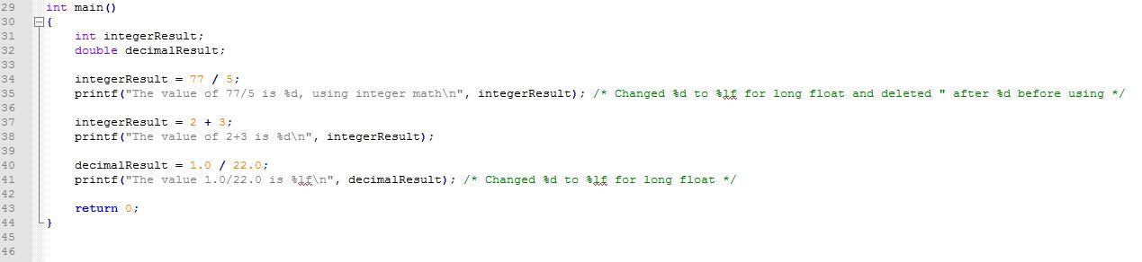

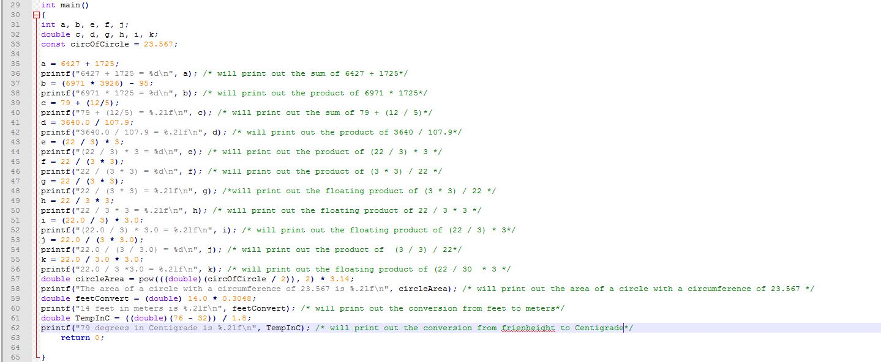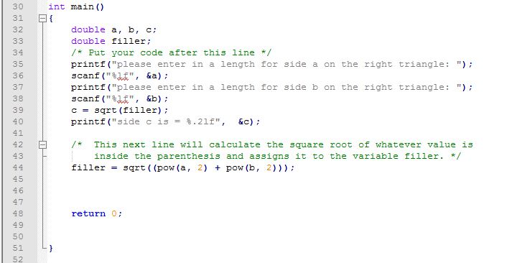

# Screen Shots

<Number the screenshots and paste here. The point of numbering the screenshots is so that you can refer to them during your discussion in the various parts above. Alternatively, you can include the screenshots in-line with the text above as part of your discussion.>

Screenshots are listed 1-5

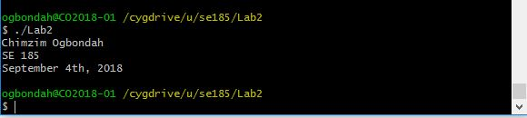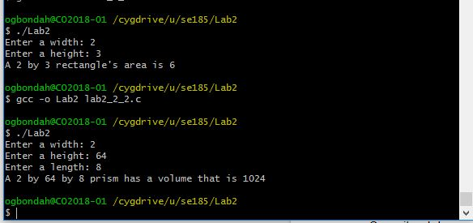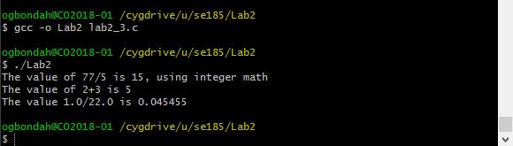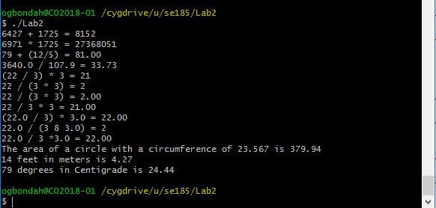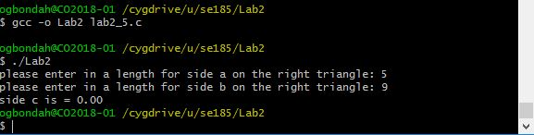

# Screen Shots

<Number the screenshots and paste here. The point of numbering the screenshots is so that you can refer to them during your discussion in the various parts above. Alternatively, you can include the screenshots in-line with the text above as part of your discussion.>